Project Report

Goodnight Gorilla game

For our project the book we took inspiration from was Goodnight Gorilla written by Peggy Rathmann. Our design process was pretty straight forward, we created a very rough map layout, laid out where some of the NPCs and other interactable objects would be, then started on development once everything was fine tuned. We separated our workload into two distinct categories, programming and asset creation. Ben wrote most of the code in Unity and overall game design for the project, and Dante designed all of the assets alongside helping with coding out any bugs that may have occurred. The assets were all created in a program called Aseprite. The assets stuck to a mostly monochromatic palette of just eight colors, this was to help create a nightly feel while keeping everything look like it belongs in the same project. This allowed for fast asset creation with the time frame given to us. One of the bugs presented to us was getting the animals to follow in a straight line behind the player. With the time left that we had, any solution seemed just out of reach. The system that allowed the animals to follow the player involved the spawning of waypoints. Given a few more days we might have been able to give the animals hitboxes that collided with terrain objects and fine tuning the pathing system. Another thing we would’ve liked to add if there were more time would be cutscenes and audio. The game lacks any sort of audio feedback, maybe if the player got close to a guard or camera some sort of audio cue plays to alert them so they can react accordingly. The cutscenes would’ve just added nice context to the game, at the state we had it at it just drops you in the game and once you complete it that’s it. It would’ve been more rewarding to see some sort of cutscene for when the player wins the game. Cutscenes could also give vital context to the story of the game. Animations would have been nice but that would have likely been too big an ask due to the fact that we made all the assets ourselves. Stack overflow helped sort out any of the bugs that were in the project. Most systems rely on global variables and layer collisions since they allow for a quick and easy way to get gameplay systems working.

The development started by coming up with the gameplay systems where the gorilla could move around, free following animals while avoiding guards, then finally get to the end of the map with all animals. We designed a map and added basic enemy locations. We plotted out how animals would follow players and interact with enemies. Changes were small and made over time during development. This incremental change lead to a small amount of bugs overall.

1. 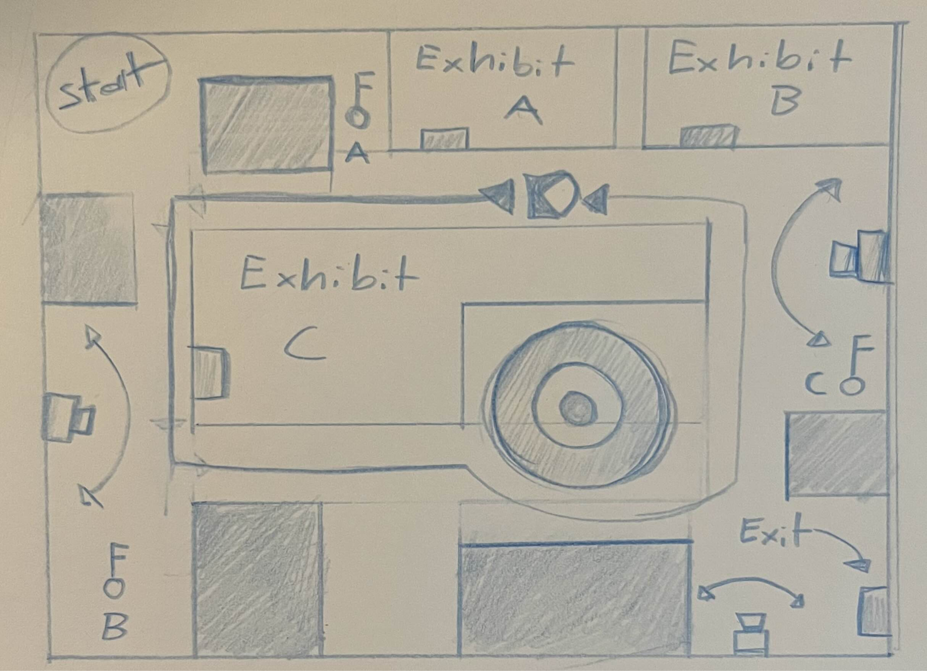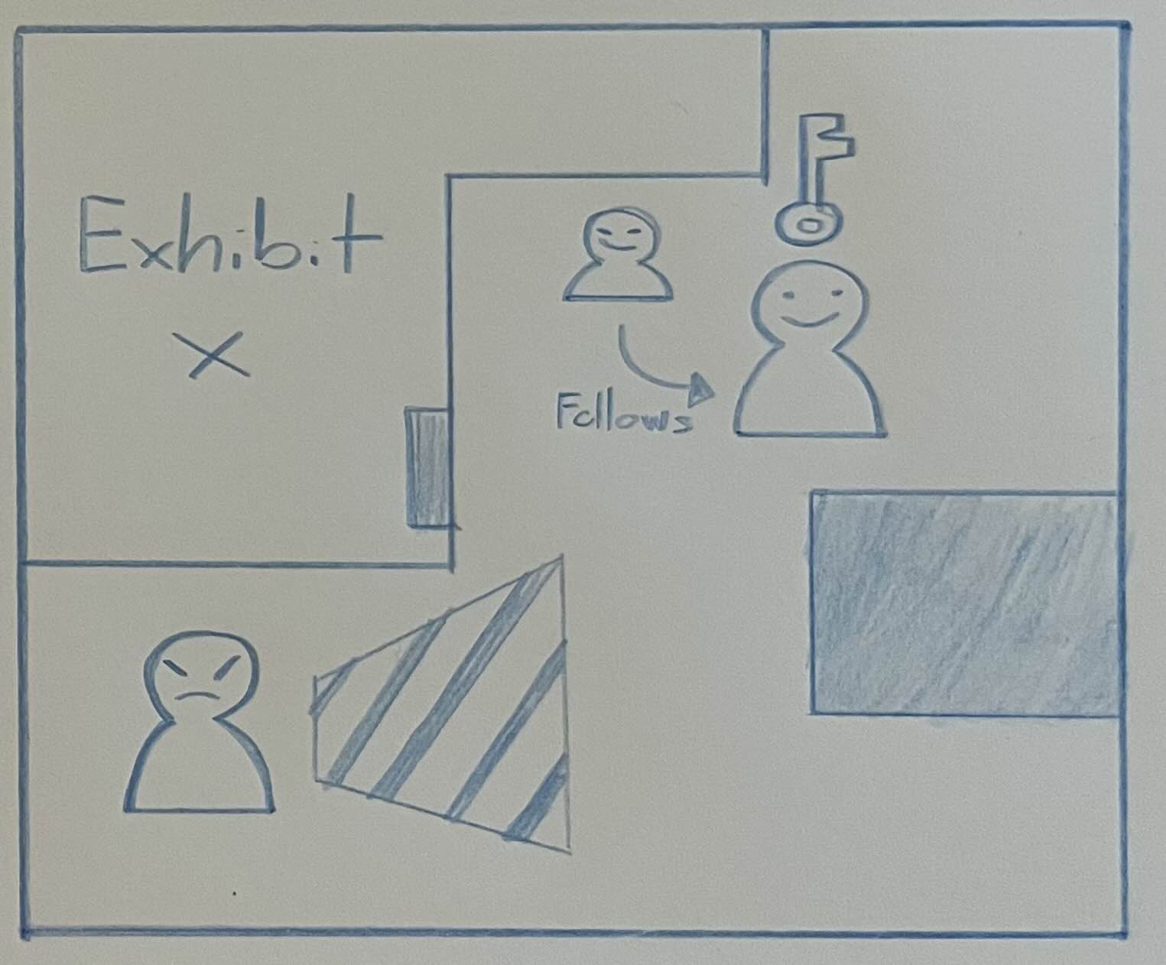

Unity References most often used:

<https://docs.unity3d.com/Manual/scripting.html>

https://stackoverflow.com/